# AI LAB EXPERIMENT NO: 9

**ALGORITHM:-**

**Step 1**: Start

**Step 2**: Each piece of evidence is represented by a separate belief function

**Step 3**: Combination rules are then used to successively fuse all these belief

functions in order to obtain a belief function representing all available evidence.

**Step 4**: Specifically, the combination (called the joint mass) is calculated from

the two sets of masses m1 and m2 in the following manner:

* m1,2(∅) =0
* m1,2(A)=(m1⊕m2)(A)=(1/1−K ) ∑B∩C=A≠∅ m1(B) m2(C)

where,

* K=∑B∩C=∅ m1(B) m2(C) K

K is a measure of the amount of conflict between the two mass sets. **Step 5**: In python Mass-Function has the built-in combination rules. **Step 6**: Stop

# CODE:-

from numpy import *

def DempsterRule(m1, m2):

## extract the frame of discernment sets=set(m1.keys()).union(set(m2.keys())) result=dict.fromkeys(sets,0)

## Combination process for i in m1.keys():

for j in m2.keys():

if set(str(i)).intersection(set(str(j))) == set(str(i)): result[i]+=m1[i]*m2[j]

elif set(str(i)).intersection(set(str(j))) == set(str(j)): result[j]+=m1[i]*m2[j]

## normalize the results

f= sum(list(result.values())) for i in result.keys(): result[i] /=f

return result

m1 = {'a':0.4, 'b':0.2, 'ab':0.1, 'abc':0.3}

m2 = {'b':0.5, 'c':0.2, 'ac':0.3, 'a':0.0}

print(DempsterRule(m1, m2))

# OUTPUT:-

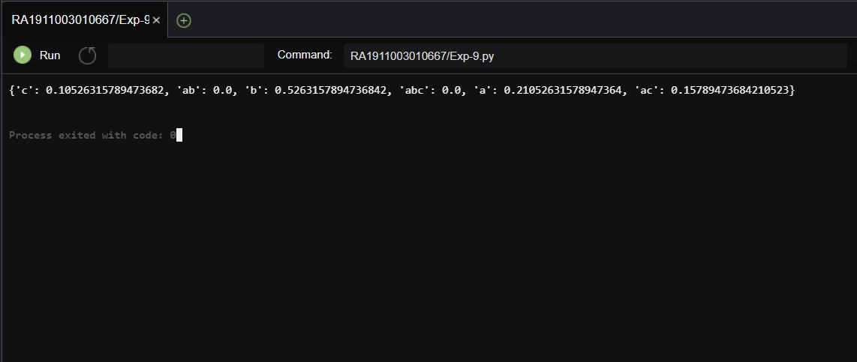

**RESULT:-**

Hence, the Implementation of Dempster Shafer Theory is done successfully.

m1 = {'a':0.4, 'b':0.2, 'ab':0.1, 'abc':0.3}

m2 = {'b':0.5, 'c':0.2, 'ac':0.3, 'a':0.0}

print(DempsterRule(m1, m2))

# OUTPUT:-



**RESULT:-**

Hence, the Implementation of Dempster Shafer Theory is done successfully.